http://www.unisim.edu.sg/about-unisim/Overview/PublishingImages/UniSIM_logo.gif

**COR165**

**Thinking Critically**

**Tutor-Marked Assignment 1**

**July 2016 Presentation**

Name: Lim Hui Qin

Student ID: Z1610579

Contents

Section A 3

Question 1 3

Question 2 3

Question 3 3

Question 4 4

Question 5 4

Question 6 4

Question 7 5

Question 8 5

Question 9 5

Question 10 6

Section B 7

Question 11 7

Question 12 (a) 8

Question 12 (b) 10

Section C 12

Question 13 12

References 13

# Section A

## Question 1

|  |  |  |
| --- | --- | --- |
| Sentence | : | 'Jane fell in love and got married.' This is a statement. |
| True / False | : | True. |
| Justification | : | This is correctly classified as a statement because it takes a proposition. This is a compound statement formed using the conjunction “and”. Without the conjunction, the sentence will be separated into “Jane fell in love”, “Jane got married”. |

## Question 2

|  |  |  |
| --- | --- | --- |
| Sentence | : | 'If you don’t have a degree, then your promotion opportunities are limited.' This is an argument. |
| True / False | : | False. |
| Justification | : | An argument is made up of premises and conclusion. This is a conditional statement, not an argument where the antecedent is a premise and the consequent is the conclusion. The above makes having a “degree” a condition for “promotion opportunities”. |

## Question 3

|  |  |  |
| --- | --- | --- |
| Sentence | : | 'Almost all mathematicians love music. Nash is a mathematician. So, Nash loves music.' By the principle of charity, this is best read as an inductive argument. |
| True / False | : | True. |
| Justification | : | By principle of charity, statement should be interrelated in a way most favorable to author. This is read as an inductive statement because the conclusion “Nash loves music” is highly plausible and not true beyond. Author did not explicitly mention that “All mathematicians love music” but used “'Almost all” instead. |

## Question 4

|  |  |  |
| --- | --- | --- |
| Sentence | : | 'A sound argument must have a true conclusion.' |
| True / False | : | True. |
| Justification | : | The two criteria for a deductive argument to be sound are to have a valid structure and true premises. Hence it is necessary that a sound argument have a true conclusion, not overlooking that argument should be valid as well. |

## Question 5

|  |  |  |
| --- | --- | --- |
| Sentence | : | 'A weak argument must have a false conclusion.’ |
| True / False | : | False. |
| Justification | : | The strength of an argument is determined by the evidence used to support the conclusion. A weak argument can have a true conclusion as well because strength and truth of premises are independent criteria that affect the cogency of an inductive argument. |

## Question 6

|  |  |  |
| --- | --- | --- |
| Sentence | : | 'Romeo would have gone against his family only if he loved Juliet enough. But, Romeo didn’t go against his family. So, he didn’t love Juliet enough.' This is a valid argument. |
| True / False | : | True. |
| Justification | : | This is an instance of modus ponens where the conclusion is affirmed through the inferences of the conditional statement. Given Romeo would go against his family on the condition that he loved Juliet enough, since he did not go against his family, it is inferred that he did not love Juliet enough. |

## Question 7

|  |  |  |
| --- | --- | --- |
| Sentence | : | 'Either Tom or Jerry will not play in tomorrow’s game. Tom will surely not play due to an injury. So, Jerry will certainly play.' This is a valid argument. |
| True / False | : | True. |
| Justification | : | This is an instance of affirming a disjunction. The options of “playing in the game” and “not playing in the game” are mutually exclusive, it is logically impossible for both options to co-exist. Hence this is a valid argument since the disjunction is exclusive. |

## Question 8

|  |  |  |
| --- | --- | --- |
| Sentence | : | 'Some girls are good-looking. Some good-looking people are arrogant. So, some girls are arrogant.' This is a valid argument. |
| True / False | : | True. |
| Justification | : | This is an instance of hypothetical syllogism which is a valid argument. The conclusion is based on the hypothesis of the two premises. The term “good-looking” links up both premises, thus the conclusion that “some girls are arrogant”. |

## Question 9

|  |  |  |
| --- | --- | --- |
| Sentence | : | 'Either Constructive Dilemma or Destructive Dilemma is a valid form of argument. But Constructive Dilemma is not a valid form of argument. So, Destructive Dilemma is a valid form of argument.' This is a sound argument. |
| True / False | : | False. |
| Justification | : | This is a valid argument but not a sound argument because both Constructive Dilemma and Destructive Dilemma are valid forms of arguments. “Constructive Dilemma is not a valid form of argument” is untrue, hence statement is unsound. Although premises are untrue, this is an instance of disjunctive syllogism where one premise is a disjunction and the other premise is negation of a disjunction. |

## Question 10

|  |  |  |
| --- | --- | --- |
| Sentence | : | 'Research shows that only lifestyle-related factors, such as smoking and drinking, contribute significantly to the risk of contracting cancer. Joanne does not smoke or drink. So, Joanne will probably not get cancer.' This is a strong argument. |
| True / False | : | False. |
| Justification | : | This is not a strong argument due to insufficient supporting evidence to show that “only lifestyle-related factors … contribute significantly to the risk of contracting cancer”. Argument only state “Research shows” but did not mention explicitly on the research sources. Additionally, this is an instance of denying the antecedent. Though “Joanne does not smoke or drink”, it is insufficient to conclude that she “will probably not get cancer”. |

# Section B

## Question 11

The two valid forms presented in this argument are modus ponens and hypothetical syllogism.

Modus ponens is a valid simple argument form that adheres to the rule of inference. To illustrate, X is a condition for Y to occur, hence when X is asserted to be true, Y must be true too. In this argument, “If a society bans the consumption of marijuana, it can’t be liberal”, X refers to the ban of marijuana consumption while Y refers to the society being non liberal. By putting this into the context of modus ponens, it can be inferred that in presence of a ban on consumption of marijuana (X is ascertained), the society is non liberal (Y is true).

Hypothetical syllogism is a form of valid argument that follows the transitivity of implication, otherwise known as chain argument. Conclusion is formed based on both of its premises which involve the use of conditional statements. From the argument –

*Premise 1:* “if a society stops people from smoking cigarettes, then it is a clear violation of an individual’s right to lead the sort of life he or she values.”

*Premise 2:* “And if a society is guilty of such a violation, it can’t be called liberal.”

Notice that in both premises, the “violation” of an individual’s right is common. In premise 1, violation is stated as a consequence while in premise 2, it is stated as a condition. Since stopping people from smoking cigarettes is a violation of individuals’ rights and such violation constitutes to a non liberal society, the argument can be summarized by the chain of argument. It can be concluded that, through inference, “if a society stops people from smoking cigarettes”, then “it can’t be called liberal”.

## Question 12 (a)

The form of argument used is categorical syllogisms where “All P are K”. The quantifier “all” is used, with the predicate “love [for] music” and subjects are “philosophers” and “mathematicians”.

All philosophers love music. Philosophers who do not love music are blocked off below.

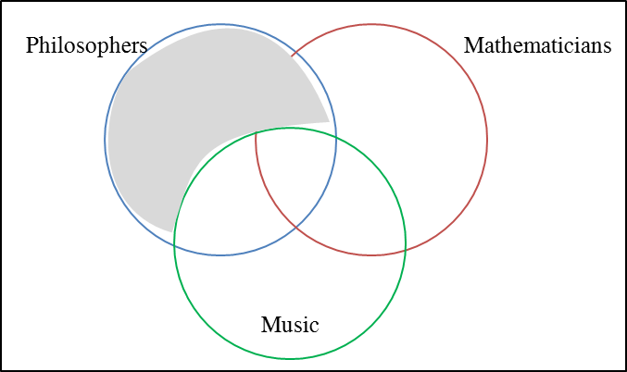

All mathematicians love music. Mathematicians who do not love music are blocked off below.

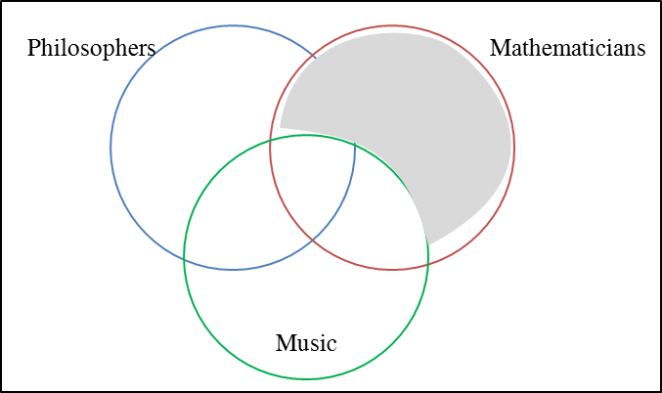

Therefore, all philosophers are mathematicians. The conclusion is represented as below.

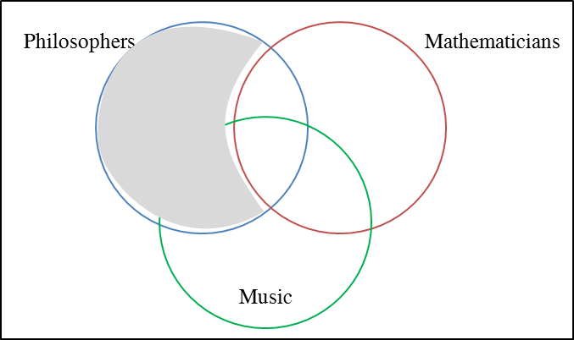

The area blocked off by conclusion is not within the area blocked off by both premises. Hence the argument is not valid. Conclusion is overstated.

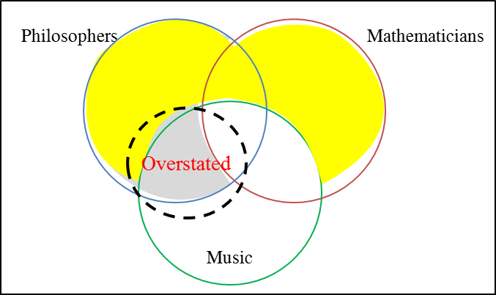

## Question 12 (b)

The form of argument used is categorical syllogisms where “No P are K”. The quantifier “no” is used, with the predicate “kind[ness]” and subjects are “god-fearing people” and “terrorists”.

No god-fearing people are terrorists. God-fearing people who are terrorists are blocked off below.

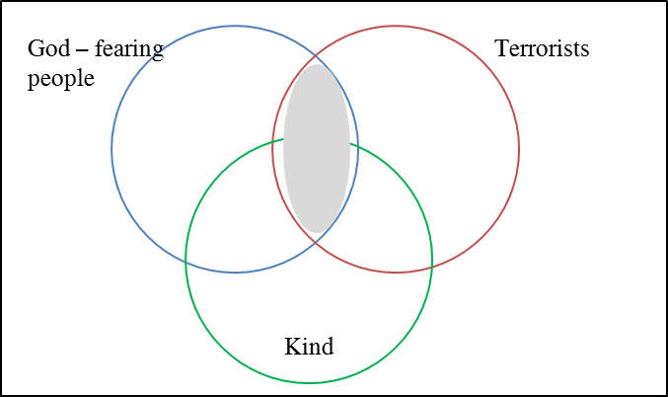

No terrorists are kind. Terrorists who are kind are blocked off below.

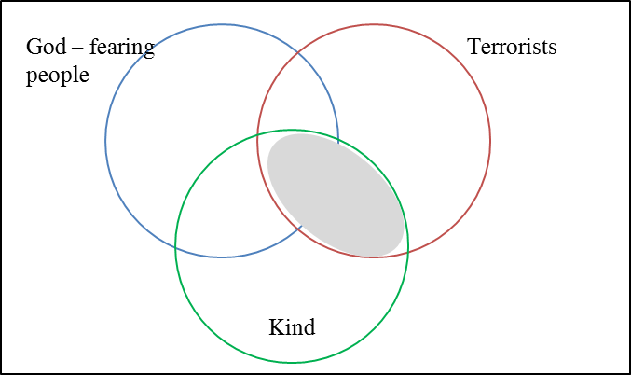

Therefore, no god-fearing people are kind. The conclusion is represented as below.

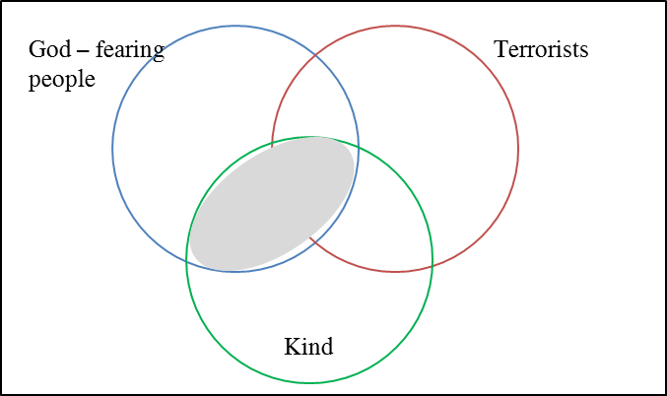

The area blocked off by conclusion is not within the area blocked off by both premises. Hence the argument is not valid. Conclusion is overstated.

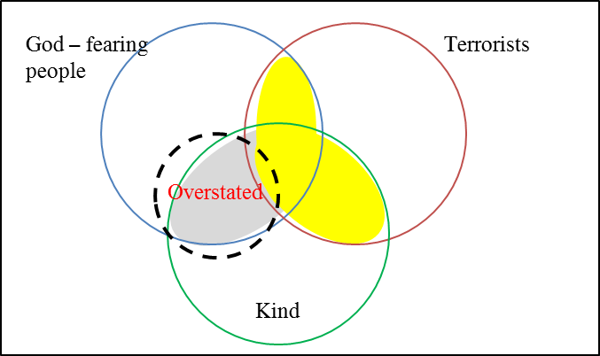

# Section C

## Question 13

Cigarette smoking in Singapore has brought about major health and environmental issues. If the sale of cigarettes is banned in Singapore, it will improve the overall health of Singaporeans and make the surrounding environment a better place. Hence the sale of cigarettes should be banned in Singapore.

If people continue to purchase cigarettes, it will undoubtedly lead to an increase in smokers’ population. If there is an increase in smoker population, there will be a rise in the number of people contracting lung diseases. Therefore, if the sale of cigarette is not banned in Singapore, there will be more people suffering from respiratory problems. According to the health advisory notice published by National Cancer Centre Singapore, smokers are 15 to 25 times more at risk of developing lung cancer and people who inhale the smoke from others have an increase chance of 30%. The Health Promotion Board of Singapore also highlighted that smoking related diseases are the nation’s top killers.

Without the sale of cigarettes in Singapore, the environmental air quality and cleanliness will see an improvement. According to World Health Organization, cigarette smoke contain more than 4000 types of chemicals, of which 10% are poisonous and 1% are cancer causing. Additionally, smokers are amongst the litter bugs caught in Singapore. They conveniently discard the cigarette butts onto road pavements and drains after smoking, tarnishing the Clean and Green City reputation of Singapore. In 2015, a man was given a hefty fine for littering of cigarette butts despite being warned several times.

To summarize, the ban of sale of cigarettes in Singapore will either improve the overall health of Singaporeans or make the surrounding environment a better place. If the overall health of Singaporeans improve, individual’s medical expenses will reduce and the body immune system will be in pink health. If the surrounding environment improves, everyone will have a better place to live, work and play in.

# References

1. By Anjana Motihar Chandra for Health Xchange, with expert input from the National Cancer Centre Singapore (NCCS), a member of the SingHealth group. (n.d.). Cigarette Smoking Is the Main Cause of Lung Cancer. Retrieved September 09, 2016, from http://www.healthxchange.com.sg/healthyliving/specialfocus/pages/cigarette-smoking-is-the-main-cause-of-lung-cancer.aspx
2. Deadly Form of Air Pollution. (n.d.). Retrieved September 09, 2016, from https://www.mindef.gov.sg/imindef/mindef_websites/topics/elifestyle/articles/smoking/deadly_form_of_air.html
3. Lung Cancer. (n.d.). Retrieved September 09, 2016, from http://www.nccs.com.sg/PatientCare/WhatisCancer/TypesofCancer/Pages/lung-cancer.aspx?p=/PatientCare
4. Moran, L. (2015). Singaporean man fined $15K for littering 34 cigarette butts. Retrieved September 09, 2016, from http://www.nydailynews.com/news/world/singaporean-man-fined-15k-littering-34-cigarette-butts-article-1.2089316
5. Second-Hand Smoke​. (n.d.). Retrieved September 09, 2016, from http://www.healthhub.sg/live-healthy/450/environmentaltobaccosmoke